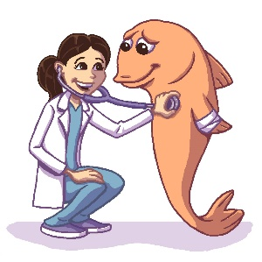
Winchester Veterinary Group
Fish Health History Form
Please e-mail completed form and any videos/photos to reception@winchestervetgroup.com prior to appointment

Environmental History
Volume of affected system (gallons or liters)

Depth of pond (if applicable)

How long has the tank been running?

Describe the substrate at the bottom(material, depth, size)

Any recent equipment failures/malfunctions? Power outages?

Describe any ornaments and décor (material etc.)

Is the tank covered?

Location of tank/pond (near windows? Trees?)

Life Support Systems
Number and type of filters? Type of media in filter(s)?

Does the tank/pond have aeration? Describe

Does the tank have a heater? Is temperature consistent?

Does the tank have a UV sterilizer? If yes, age of bulb?

Pump type and volume? What is the water turnover rate?

What type of lighting? Describe the photoperiod settings

Protein skimmers?

Maintenance
Please describe the water change schedule – how often? How much? Any water treatments used? How often is algae scrubbed? Gravel vacuumed? How are filters cleaned?

Water Quality
What is the source of water used for the tank? (ex Tap, Well, RO) Is/how is it treated prior to use?

Is water quality routinely checked? How often? Which parameters and what method? (test strips v reagent tubes v other).

Can you share recent results of
pH:________ Temp:________ Nitrite:_______ mg/L Nitrate:_______mg/L Ammonia:_______mg/L Alkalinity:_______ mg/L Hardness:________ mg/L DO:________mg/L Chloride:_________mg/L Salinity:_________ ppt
Have there been any results trending outside of the target ranges?

What is the appearance of the water? (cloudy, clear, colored etc)

***Please bring a separate sample for analysis at the appt***
Fish History
How many fish are in the tank/pond? What species? What size?

Any recent additions? Were they quarantined prior to addition? Describe quarantine procedure used

Nutrition
What type(s) and brand(s) of food do you feed? (ex flakes, floating pellets, sinking pelets, gel, live etc.)? What is the age of the food? How is it stored? How much is fed and how often?

Focusing on the Sick Fish
How many fish (and which species) are affected?

Please describe the issue in detail (date first noted, describe progression – please include any behavioral changes such as abnromal swimming, hyperactive activity, listnessness etc)

How is the appetite?

Have you tried any OTC treatments? If yes, please list drug/dose/duration. What was the result of the treatment?

Have there been any fatalities?

